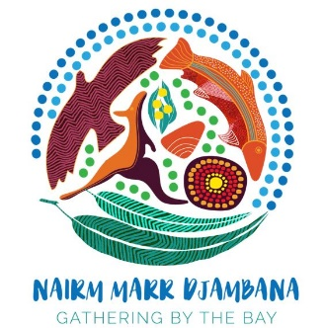
Workshop/ Group Registration Form
Group / Workshop | Name:
Address: | Date of Birth:
Home No:  Mobile No: | Email:
Emergency Contact:  Name:  Phone No:  Relationship to You: | Allergies (for Catering Purposes)
Do you agree to be photographed and recorded during the workshops / Groups?  Y/N | Are you a Member of Nairm Marr Djambana?  Y/N
Do you have access to Internet / IT equipment?  Y/N | Where did you hear about this workshop/Group?
When engaging with Nairm Marr Djambana what areas are you interested in participating:

Art Workshops | Cooking Workshop | Weaving Workshops
Craft Workshop | Yarning Circles | Music /Traditional or Modern
Cultural Workshop | Exercising Groups | Garden Groups
Life Skills Workshops | Language Workshop | Dancing Groups
Family Groups Activities ex BBQ | Sporting Groups.  (Please specify which sport) | Bush Tucker
Computer Courses | Others; (Please Specify)

